Class I Maths – 24th July 2019; Wednesday:
1. What is the shape of a full pizza and half-a-pizza? ___________________

2. How many legs will 5 elephants have? _________
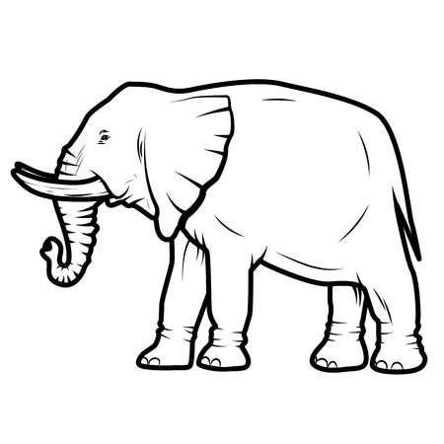

3. Find out how many horizontal and how many vertical lines in these alphabets?
i. ________ ii. ___________

4. How many Zeroes are there in the figure 1000? _______.
***************************************************************
Class II Maths – 24th July 2019; Wednesday:
1. Count how many diagonal / slanting lines in this figure?
i. _________ ii. ________

2. Four legs how many toes in all? ____________________
3. Count how many circles in all?
_____________________
4. If there are three lines in a row;
the first line is 2 centimetres in length; the second is 8 centimetres and
the third is 5 centimetres. What is the total length of the three lines?
*************************************************************
Class III Maths – 24th July 2019; Wednesday:
1. Find the sum of the following: i. 62 and 93? ________________
and ii. 96 and 7 ? _________________

2. What is the difference between i. 18 and 9? ____________________
and ii. 100 and 78? ____________________
****************************************************************
Class IV Maths – 24th July 2019; Wednesday:
7. The denominator of a fraction is thrice that of the numerator. The sum of the numerator and the denominator is 16. Find the fraction.
a. ⁷ /₁₂ [ ] b. ⁴ /₁₂ [ ] c. ³/₉ [ ] d. ⁵ /₁₁ [ ]
8. i.How many millilitres of orange juice will there be in a 2 -litre bottle? ________.
ii. How many sides does a hexagon have? _____________.
***********************************************************************
Class V Maths – 24th July 2019; Wednesday:
1. Which among the following is not a common factor of 18 and 27?
a. 1 [ ] b. 3 [ ] c. 6 [ ] d. 9 [ ]
2. Look at this word: C O N S T A N T I N O P L E :
Which among the following statements is INCORRECT?
a. The 2nd, 6th, 9th, 11th & 14th letters are Consonants ( )
b. The word has 14 letters ( )
c. The 7th and the 8th letters from the left are N & T. ( )
d. The vowel U is missing. ( )
***********************************************************************

Class VI Maths – 24th July 2019; Wednesday:
1. Look at this figure. What’s the area of the shaded region if each square is 4cm x 4 cm?

4cm
a. 300 cm² [ ] b. 212 cm² [ ] c. 200 cm² [ ] d. 288cm² [ ]
2. Here are a few Roman numerals: I, C, L, M, D
Which of the following number can be written using all the above given Roman numerals?
a.1775 [ ] b. 864 [ ] c. 1947 [ ] d. 1753 [ ]
******************************************************************************

Class VII Maths – 24th July 2019; Wednesday:
1. Numbers that come one after the other are called CONSECUTIVE NUMBERS. For example; 2, 3, 4 or 113, 114, 115 are consecutive numbers. Four consecutive numbers starting from 33 are multiplied. Which of these digits will be in the One’s / Unit’s place in the resulting product?
a. 0 [ ] b. 2 [ ] c. 5 [ ] d. 6 [ ]
2. Which of these lies between 6.3 and 6.6?
a. 6.26 [ ] b. 6.99 [ ] c. 6.05 [ ] d. 6.41 [ ]
*******************************************************************************
Class VIII Maths – 24th July 2019; Wednesday:
1. x and y are integers. x is greater than 40 and y is less than 40 . Which of the following statements is true about x-y?
a. it is equal to 80 [ ] b. it is equal to zero [ ] c. it is greater than 80 [ ] d. it is between 0 and 40 [ ]

2. Anuj is 3 years younger to Aniket. Anuj is 1 year younger to Parth. If Parth is 12 years old, how old is Aniket? a. 16 years [ ] b. 14 years [ ] c. 10 years [ ] d. 8 years [ ]

*******************************************************************************
Class IX Maths – 24th July 2019; Wednesday:
1. One morning after sunrise, Suresh was standing facing a pole. The shadow of the pole fell exactly to his right. To which direction was he facing?

a. East [ ] b West [ ] c. South [ ] d. North [ ]
.
2. A man walks 5 km toward south and then turns to the right. After walking 3 km he turns to the left and walks 4 km. And then he goes back 10 km straight. Now in which direction is he from the starting place ?

a. South East [ ] b North West [ ] c. South [ ] d. West [ ]

********************************************************************************************
Class X Maths – 24th July 2019; Wednesday:
1. If Which among the following are incorrect?
a. Volume of a cylinder = π r ² h [ ] b. Volume of a Cone = ¹ /₃ π r ² h [ ]
c. Volume of a sphere = 4 π r ² h [ ] d. Volume of a cuboid = l x b h [ ]

2. if there are 8,88,888 sewing machines are equally distributed to 888 rural centres of a district. How many sewing machines will each rural centre get?
a. 1111 [ ] b. 1001 [ ] c. 1000 [ ] d. 1077 [ ]

********************************************************************************************
Class XI Maths – 24th July 2019; Wednesday:
1. Complete the following algebraic expressions
i. (x + y )² = _____________________________
ii. (x + y ) (x -y ) = ________________________

2. Which among the following is known as Hardy-Ramanujan number?
i. 1729 [ ] ii. 9271 [ ] iii. 1279 [ ] iv. 7291 [ ]

*******************************************************************************************
Class XII Maths – 24th July 2019; Wednesday:
1. What is the average run rate made by a player if he hits 6 sixes and 8 fours in 24 balls
i. 1.5625 [ ] ii. 2.8333 [ ] iii. 3. 25 [ ] iv. 3.9 [ ]

2. If there are 888888 bicycles distributed in 888 rural schools of a district, how many bicycles will each school get?
i. 1111 [ ] ii. 1001 [ ] iii. 3. 1077 [ ] iv. 1000 [ ]
*******************************************************************************************

